University of West Indies Open Campus

Assignment 4-Multimedia Project-How to Decorate an Easter Basket
Project: Section 1
Individual Storyboard

Completed in partial fulfilment of the course: EDID6508 - Developing Instructional Media

Completed by
Arlyn Linton-Jones
1996605185
Tutor: Dr. Leroy Hill
Date Submitted: 06-04-2015

Lesson Plan
Lesson: How to decorate a basket for Easter
Target Audience: Adults 18 years and over
Duration: 40 minutes
Goal: How to Decorate a Basket for Easter
Objectives:
By the end of the lesson students should be able to:
Arrange flowers on an Easter basket
Design an Easter basket
Decorate an Easter basket with various craft item
Display treats and sweets in an Easter basket
Prior Knowledge
As children the adults would’ve been exposed to Easter and an Easter Egg Hunt
Set Induction
Students are shown a picture of the finished product (a decorated Easter basket filled with treats) and asked to guess what it is?
Student Activities
- Students will decorate their own basket following step by step as shown in the video
- Students will share their finished product with the class.

Assessment
Students will be asked questions on decorating an Easter basket and also asked decorating tips and then a recap of the main decorating steps would be given.

Level 1: Inform Learner of Objective
PROJECT: Easter Craft Class SCREEN: 1 OF 14
DATE: 01/04/2015
MULTIMEDIA STORYBOARD
SCENE DESCRIPTION: This is the splash screen and the main menu of the project. It will include animated images to gain user attention.

SCREEN LAYOUT:
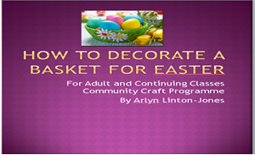
Text Attributes: Text is Tahoma and rounded Arial font in various sizes
Still Images: Easter basket and vector text boxes
Moving Images
Animation: The text box with the features will fade in. The text inside the box will also fade in one by one.
Video: None
Audio
Speech: Welcome to how to decorate a basket for Easter for the adult class of Community Craft Programme presented by Arlyn Linton-Jones
Music :( Background Music) In the Hall of the Mountain King (Dovrebuggens Hall) by Edvard Greig
Sound Effects: None
Interactivity: User will proceed to next screen when they press enter. It will proceed after a particular time. The ‘ENTER’ will allow the user to bypass the intro.
Navigation
From Screens: First screen
To Screens: The main menu for users to choose
Time: 10secs
Level 2: Gain Attention
PROJECT: Easter Craft Class SCREEN: 2 OF 14
DATE: 01/04/2015
MULTIMEDIA STORYBOARD
SCENE DESCRIPTION:
This is the second screen that the user will see after the splash screen. The splash screen will be a flash animated screen to solicit user interaction.

SCREEN LAYOUT:
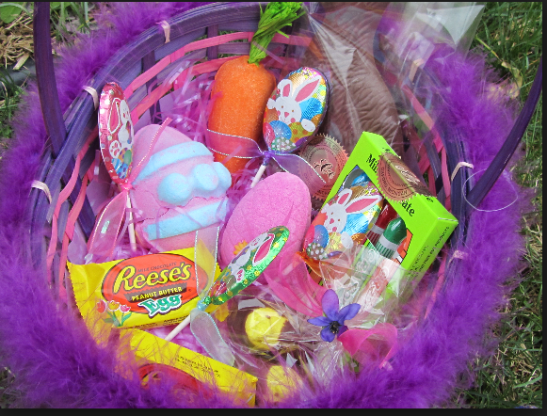
Text Attributes: All text is in ARIAL font,
Still Images: Decorated Easter basket Vector images used as background for text/buttons. A JPEG image of the Easter Basket.
Moving Image Animation: It is expected that the arrows will be animated
Video: Welcome video will be added above in this section
Audio Speech: Students are asked “Can you guess what this is?” as they are shown an image of a decorated Easter basket
Music :( Background Music) In the Hall of the Mountain King (Dovrebuggens Hall) by Edvard Greig
Sound Effects: None
Interactivity: Each arrow will point to the appropriate screen; the text buttons will be hyperlinked to its appropriate screen. The help section will point to a bookmarked FAQ section.
Navigation
From Screens: Splash screen
To Screens: To all screens except the splash screen
Time: 1min

Level 3: Stimulate recall of Prior Knowledge Prior Knowledge
PROJECT: Easter Craft Class SCREEN: 3 OF 14
DATE: 01/04/2015
MULTIMEDIA STORYBOARD
SCENE DESCRIPTION:
This is the third screen that the user will see after the splash screen. The splash screen will be a flash animated screen to solicit user interaction.
SCREEN LAYOUT:
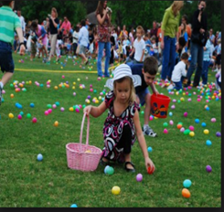
Text Attributes: All text is in ARIAL font,
Still Images: A JPEG image of children on an Easter Egg Hunt.
Moving Image Animation: It is expected that the arrows will be animated
Audio Speech: Students are asked to reminisce and share a story of when they were a child and they did Easter Egg Hunts”. Do you remember these days?” How it was a plain basket. Well today I am going to teach you how to decorate those baskets with flowers, tulle, butterflies and jewels.
Music :( Background Music) In the Hall of the Mountain King (Dovrebuggens Hall) by Edvard Greig
Sound Effects: None
Interactivity: Each arrow will point to the appropriate screen; the text buttons will be hyperlinked to its appropriate screen.
Navigation
From Screens: Splash screen
To Screens: To all screens except the splash screen
Time: 1min
Level 4: Present Material
PROJECT: Easter Craft Class SCREEN: 4 OF 14
DATE: 01/04/2015
MULTIMEDIA STORYBOARD
SCENE DESCRIPTION:
This is the fourth screen that the user will see after the splash screen. The splash screen will be a flash animated screen to solicit user interaction.
SCREEN LAYOUT: 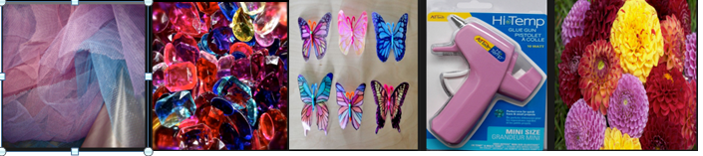
Text Attributes: All text is in ARIAL font,
Still Images: A JPEG image of the tulle, jewels, butterflies glue gun and flowers.
Moving Image Animation: It is expected that the arrows will be animated
Audio Speech: First we get our supplies
Music :( Background Music) In the Hall of the Mountain King (Dovrebuggens Hall) by Edvard Greig
Sound Effects: None
Interactivity: Each arrow will point to the appropriate screen; the text buttons will be hyperlinked to its appropriate screen.
Navigation
From Screens: Previous Screen
To Screens: Next Screen
Title slides in from the left
Image fades in. Narration synched with corresponding text. When hover over an item text becomes green
Time: 1min
PROJECT: Easter Craft Class SCREEN: 5 OF 14
DATE: 01/04/2015
MULTIMEDIA STORYBOARD
SCENE DESCRIPTION:
This is the fifth screen that the user will see after the splash screen. The splash screen will be a flash animated screen to solicit user interaction.
SCREEN LAYOUT:
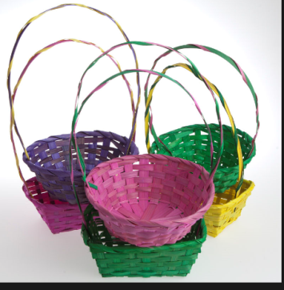
Text Attributes: All text is in ARIAL font,
Still Images: A JPEG image of the empty Easter Basket.
Moving Image Animation: It is expected that the arrows will be animated
Audio Speech: Obtain an empty colourful basket. Using the hot glue gun we will stick the flowers, ribbons, tulle, butterflies and ribbon onto the basket one by one to have the design we saw at the beginning of the lesson.
Music :( Background Music) In the Hall of the Mountain King (Dovrebuggens Hall) by Edvard Greig
Interactivity: Each arrow will point to the appropriate screen; the text buttons will be hyperlinked to its appropriate screen.
Navigation
From Screens: Previous Screen
To Screens: Next Screen
Title slides in from the left
Image fades in. Narration synched with corresponding text. When hover over an item text becomes green
Time: 1min
Level 5: Provide guidance for learning
PROJECT: Easter Craft Class SCREEN: 6 OF 14
DATE: 01/04/2015
MULTIMEDIA STORYBOARD
SCENE DESCRIPTION:
This is the sixth screen that the user will see after the splash screen. The splash screen will be a flash animated screen to solicit user interaction.
SCREEN LAYOUT:
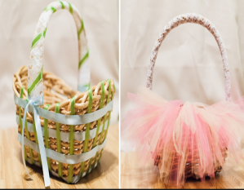
Text Attributes: All text is in ARIAL font,
Still Images: A JPEG image of the Easter Basket with tulle.
Moving Image Animation: It is expected that the arrows will be animated
Audio Speech: Let’s begin. First we start with the tulle we will hot glue this on going around the basket. Refer to the picture as shown.
Music :( Background Music) In the Hall of the Mountain King (Dovrebuggens Hall) by Edvard Greig
Interactivity: Each arrow will point to the appropriate screen; the text buttons will be hyperlinked to its appropriate screen.
Navigation
From Screens: Previous Screen
To Screens: Next Screen
Title slides in from the left
Image fade in.Narration synched with corresponding text. When hover over an item text becomes green
Time: 5 min

PROJECT: Easter Craft Class SCREEN: 7 OF 14
DATE: 01/04/2015
MULTIMEDIA STORYBOARD
SCENE DESCRIPTION:
This is the seventh screen that the user will see after the splash screen. The splash screen will be a flash animated screen to solicit user interaction.
SCREEN LAYOUT:
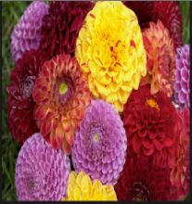
Text Attributes: All text is in ARIAL font,
Still Images: A JPEG image of the flowers.
Moving Image Animation: It is expected that the arrows will be animated
Audio Speech: Then we hot glue on the flowers in the designed as shown on the finished basket.
Music :( Background Music) In the Hall of the Mountain King (Dovrebuggens Hall) by Edvard Greig
Interactivity: Each arrow will point to the appropriate screen; the text buttons will be hyperlinked to its appropriate screen.
Navigation
From Screens: Previous Screen
To Screens: Next Screen
Title slides in from the left
Image fade in.Narration synched with corresponding text.When hover over an item text becomes green
Time: 5 min

PROJECT: Easter Craft Class SCREEN: 8 OF 14
DATE: 01/04/2015
MULTIMEDIA STORYBOARD
SCENE DESCRIPTION:
This is the eighth screen that the user will see after the splash screen. The splash screen will be a flash animated screen to solicit user interaction.
SCREEN LAYOUT:
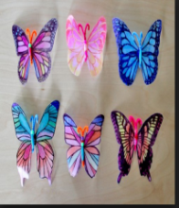
Text Attributes: All text is in ARIAL font,
Still Images: A JPEG image of the butterflies.
Moving Image Animation: It is expected that the arrows will be animated
Audio Speech: Add a butterfly to the side for style.
Music :( Background Music) In the Hall of the Mountain King (Dovrebuggens Hall) by Edvard Greig
Interactivity: Each arrow will point to the appropriate screen; the text buttons will be hyperlinked to its appropriate screen.
Navigation
From Screens: Previous Screen
To Screens: Next Screen
Title slides in from the left
Image fade in.Narration synched with corresponding text. When hover over an item text becomes green
Time: 5min

PROJECT: Easter Craft Class SCREEN: 9 OF 14
DATE: 01/04/2015
MULTIMEDIA STORYBOARD
SCENE DESCRIPTION:
This is the ninth screen that the user will see after the splash screen. The splash screen will be a flash animated screen to solicit user interaction.
SCREEN LAYOUT:
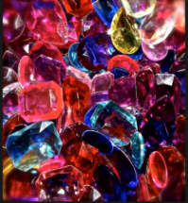
Text Attributes: All text is in ARIAL font,
Still Images: A JPEG image of the jewels.
Moving Image Animation: It is expected that the arrows will be animated
Audio Speech: Then add in the jewels on the handle.
Music :( Background Music) In the Hall of the Mountain King (Dovrebuggens Hall) by Edvard Greig
Interactivity: Each arrow will point to the appropriate screen; the text buttons will be hyperlinked to its appropriate screen.
Navigation
From Screens: Previous Screen
To Screens: Next Screen
Title slides in from the left
Image fade in.Narration synched with corresponding text. When hover over an item text becomes green
Time: 5min

Level 6: Elicit Performance
PROJECT: Easter Craft Class SCREEN: 10 OF 14
DATE: 01/04/2015
MULTIMEDIA STORYBOARD
SCENE DESCRIPTION:
This is the tenth screen that the user will see after the splash screen. The splash screen will be a flash animated screen to solicit user interaction.
SCREEN LAYOUT:
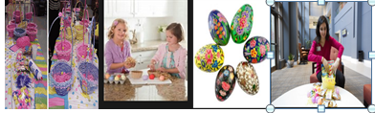
Text Attributes: All text is in ARIAL font,
Still Images: A JPEG image of the shredded paper, decorated eggs and candy in a basket
Moving Image Animation: It is expected that the arrows will be animated
Audio Speech: When all your craft work has dried, place the shredded paper inside the decorated basket and then place the decorated eggs on top. Feel free to put in some candy as well.
Music :( Background Music) In the Hall of the Mountain King (Dovrebuggens Hall) by Edvard Greig
Interactivity: Each arrow will point to the appropriate screen; the text buttons will be hyperlinked to its appropriate screen.
Navigation
From Screens: Previous Screen
To Screens: Next Screen
Title slides in from the left
Image fade in.Narration synched with corresponding text. When hover over an item text becomes green
Time: 5min

Level 7: Provide feedback
PROJECT: Easter Craft Class SCREEN: 11 OF 14
DATE: 01/04/2015
MULTIMEDIA STORYBOARD
SCENE DESCRIPTION:
This is the eleventh screen that the user will see after the splash screen. The splash screen will be a flash animated screen to solicit user interaction.
SCREEN LAYOUT:

Text Attributes: All text is in ARIAL font,
Still Images: A JPEG image of the finished decorated basket filled with shredded paper and
Moving Image Animation: It is expected that the arrows will be animated
Audio Speech: Well Done! You have decorated your first Easter basket like a professional. Feel free to take a picture and email it to me at arlyn.lintonjones@my.open.uwi.edu so I can share my thoughts.
Music :( Background Music) In the Hall of the Mountain King (Dovrebuggens Hall) by Edvard Greig
Interactivity: Each arrow will point to the appropriate screen; the text buttons will be hyperlinked to its appropriate screen.
Navigation
From Screens: Previous Screen
To Screens: Next Screen
Title slides in from the left
Image fade in.Narration synched with corresponding text. When hover over an item text becomes green
Time: 30 sec
Level 8: Assess Performance
PROJECT: Easter Craft Class SCREEN: 12 OF 14
DATE: 01/04/2015
MULTIMEDIA STORYBOARD
SCENE DESCRIPTION:
This is the twelfth screen that the user will see after the splash screen. The splash screen will be a flash animated screen to solicit user interaction.
SCREEN LAYOUT:

Text Attributes: All text is in ARIAL font,
Still Images: A JPEG image of a questions animated image
Moving Image Animation: It is expected that the arrows will be animated
Audio Speech: Are they any questions? Well I have one .Why do you think it’s better to use the glue gun for this process?
Music :( Background Music) In the Hall of the Mountain King (Dovrebuggens Hall) by Edvard Greig
Interactivity: Each arrow will point to the appropriate screen; the text buttons will be hyperlinked to its appropriate screen.
Navigation
From Screens: Previous Screen
To Screens: Next Screen
Title slides in from the left
Image fade in.Narration synched with corresponding text. When hover over an item text becomes green
Time: 5min

Level 9: Enhance retention and transfer
PROJECT: Easter Craft Class SCREEN 13 OF 14
DATE: 01/04/2015
MULTIMEDIA STORYBOARD
SCENE DESCRIPTION:
This is the thirteenth screen that the user will see after the splash screen. The splash screen will be a flash animated screen to solicit user interaction.
SCREEN LAYOUT:

Text Attributes: All text is in ARIAL font,
Still Images: A JPEG image of a questions animated image
Moving Image Animation: It is expected that the arrows will be animated
Audio Speech: Let’s review the steps for decorating a basket for Easter
Music :( Background Music) In the Hall of the Mountain King (Dovrebuggens Hall) by Edvard Greig
Interactivity: Each arrow will point to the appropriate screen; the text buttons will be hyperlinked to its appropriate screen.
Navigation
From Screens: Previous Screen
To Screens: Next Screen (Conclusion Screen)
Title slides in from the left. Image fade in.Narration synched with corresponding text

Time: 1min

PROJECT: Easter Craft Class SCREEN: 14 OF 14
DATE: 01/04/2015
MULTIMEDIA STORYBOARD
SCENE DESCRIPTION:
This is the fourteenth screen that the user will see after the splash screen. The splash screen will be a flash animated screen to solicit user interaction.
SCREEN LAYOUT:
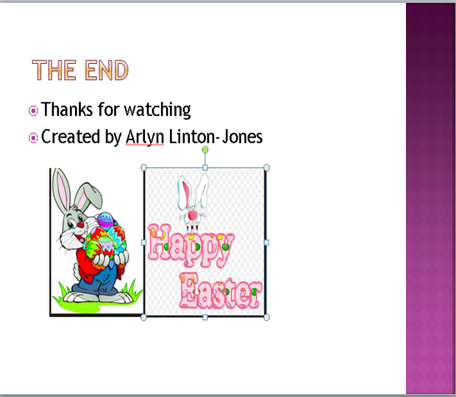
Text Attributes: All text is in ARIAL font,
Still Images: A JPEG image of a questions animated image
Moving Image Animation: It is expected that the arrows will be animated
Audio Speech: The end thanks for watching. Happy Easter
Music :( Background Music) In the Hall of the Mountain King (Dovrebuggens Hall) by Edvard Greig
Interactivity: Each arrow will point to the appropriate screen; the text buttons will be hyperlinked to its appropriate screen.
Navigation
From Screens: Previous Screen
To Screens: Introduction Screen
Title slides in from the left. Image fade in.Narration synched with corresponding text

Time: 10 sec

